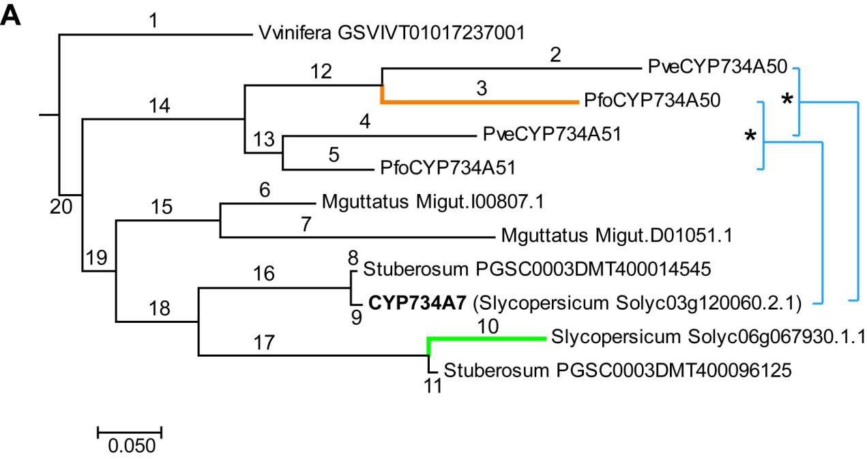

B
tree | dLRT1 | test 1 p-value | dLRT2 | test 2 p-value
tree-branch1 | -3E-05 | 1 | -3E-05 | 1
tree-branch2 | 4.919232 | 0.085 | 0 | 1
tree-branch3 | 9.414706 | 0.009 | 0.731492 | 0.392
tree-branch4 | 0 | 1 | 0 | 1
tree-branch5 | 0 | 1 | 0 | 1
tree-branch6 | 0 | 1 | 0 | 1
tree-branch7 | 5.950938 | 0.051 | 1.98208 | 0.159
tree-branch8 | 0 | 1 | 0 | 1
tree-branch9 | 0 | 1 | 0 | 1
tree-branch10 | 8.076018 | 0.018 | 4.27234 | 0.039
tree-branch11 | 1.238478 | 0.538 | 0 | 1
tree-branch12 | 0.35914 | 0.836 | 0 | 1
tree-branch13 | 0 | 1 | 0 | 1
tree-branch14 | 4.83247 | 0.089 | 1.763154 | 0.184
tree-branch15 | 2.33419 | 0.311 | 2.33419 | 0.127
tree-branch16 | 3.463792 | 0.177 | 1.667726 | 0.197
tree-branch17 | 3.083654 | 0.214 | 0.311054 | 0.577
tree-branch18 | 1.122878 | 0.570 | 1.028196 | 0.311
tree-branch19 | 0 | 1 | 0 | 1
tree-branch20 | 0 | 1 | 0 | 1

